Business Intelligence (CIS 5270 )

Project-1: Tableau Project

*Topic: Call Center dataset analysis*

Team members: Nagender Chauhan & Lekha Ajit Kumar

INTRODUCTION

We selected the Call Center dataset from the provided choices, and we plan to analyze the performance of call centers and channels. Analyzing the data based on customers is valuable and important for the company to know its customers. For instance, the firm can focus on cities that have less customer satisfaction and increase its performance. Knowing your customers, for example, their call reasons, average call durations, and their complaints, can give you some strategic ideas to improve the company and customer relations. Using the call center channels might give you investment ideas as to which channel you should improve, or stop the investment for that channel, or hire more talented staff for that channel. A consumer-based call center may help you improve complaint, response, and analytics rates, and solutions can evaluate call center staff and evaluate their customer service KPI indicators to multiple objectives. Because the data is provided in an interactive, intuitive, and visual manner, it is straightforward to see, absorb, evaluate, and share critical data, saving time and boosting cross-departmental cooperation.

In order to achieve our goals, we will be using various data analysis techniques, including exploratory data analysis, visualization, and statistical analysis. We will be looking for relationships between the different variables in our dataset and using data visualization tools to help us better understand our data. Our aim is to present the analysis by state and city using call center data, to demonstrate the performance of the call centers and the activity of the consumers, and to show the analysis of the call center channels.

Ultimately, our goal is to use the insights gained from the analysis to make data-driven decisions and improve the call center's performance. This project will provide valuable information that will help optimize operations and better serve the customers.

DATA DESCRIPTION

| Call Center | This column contains the location of the call centre.  An example value: Baltimore/MD |
| --- | --- |
| Call Timestamp | It consists of the date when the call was made.  An example value:11/10/2020 |
| Channel | The data set has 4 unique channels through which customers can reach out to the call centre. They are call centre, web, chatbot and email. |
| City | City name from which the call was issued  An example value: Detroit |
| Customer Name | The name of the customer who raised an issue.  An example value: Analise Gairdner |
| Id | Unique id for every call log  An example value: QGK-72219678-w-102139-KY |
| Reason | Why did the customer call? This column has only 3 reasons for which a customer can call. They are Billing Questions, Payments and Service Outages. |
| Response Time | How long did it take to respond to the call? This column consists of their distinct values, they are Within SLA, Above SLA and Below SLA. |
| Sentiment | The feedback of the customer after the call. There are 6 distinct types of feedback the customer can give. They are as follows Very Negative, Negative, Neutral, Very Positive and Positive. |
| State | The state name from which the call was issued.  An example value: Oregon |
| Avg Call Duration in Seconds | The Average call duration of a single call in seconds.  An example value: 118 |
| Avg Call Duration in Mins | The Average call duration of a single call in Minutes.  An example value: 1:18 |
| Average Customer Satisfaction | The average customer satisfaction rate is in the range of 1-10.  An example value: 7 |
| Call Duration | The call duration of a single call in Seconds.  An example value: 120 |
| Csat Score | Customer satisfaction score. The range of the score is between 1-10.  An example value: 8 |
| Sat rate | Total Satisfaction score. The range of the score is between 1-10.  An example value: 6 |
| Total Calls Received | It shows the Total Calls Received from a particular customer on a specific date.  An example value: 1 |

DATA CLEANING

1. We had no values for the column “Average customer Satisfaction” for a few of the rows (13% of the data set of about 33k rows) so we took an average of the remaining data for that column and added in the values via Excel formula.

Pre-Data Cleaning

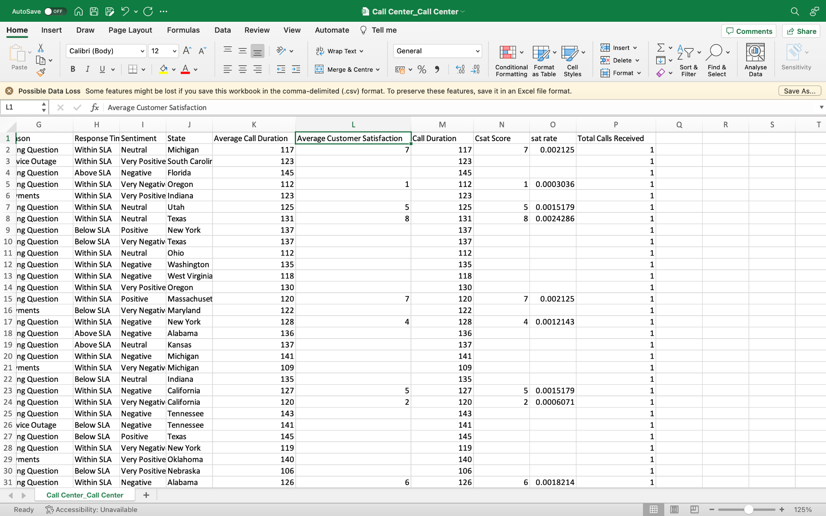

Post-Data Cleaning

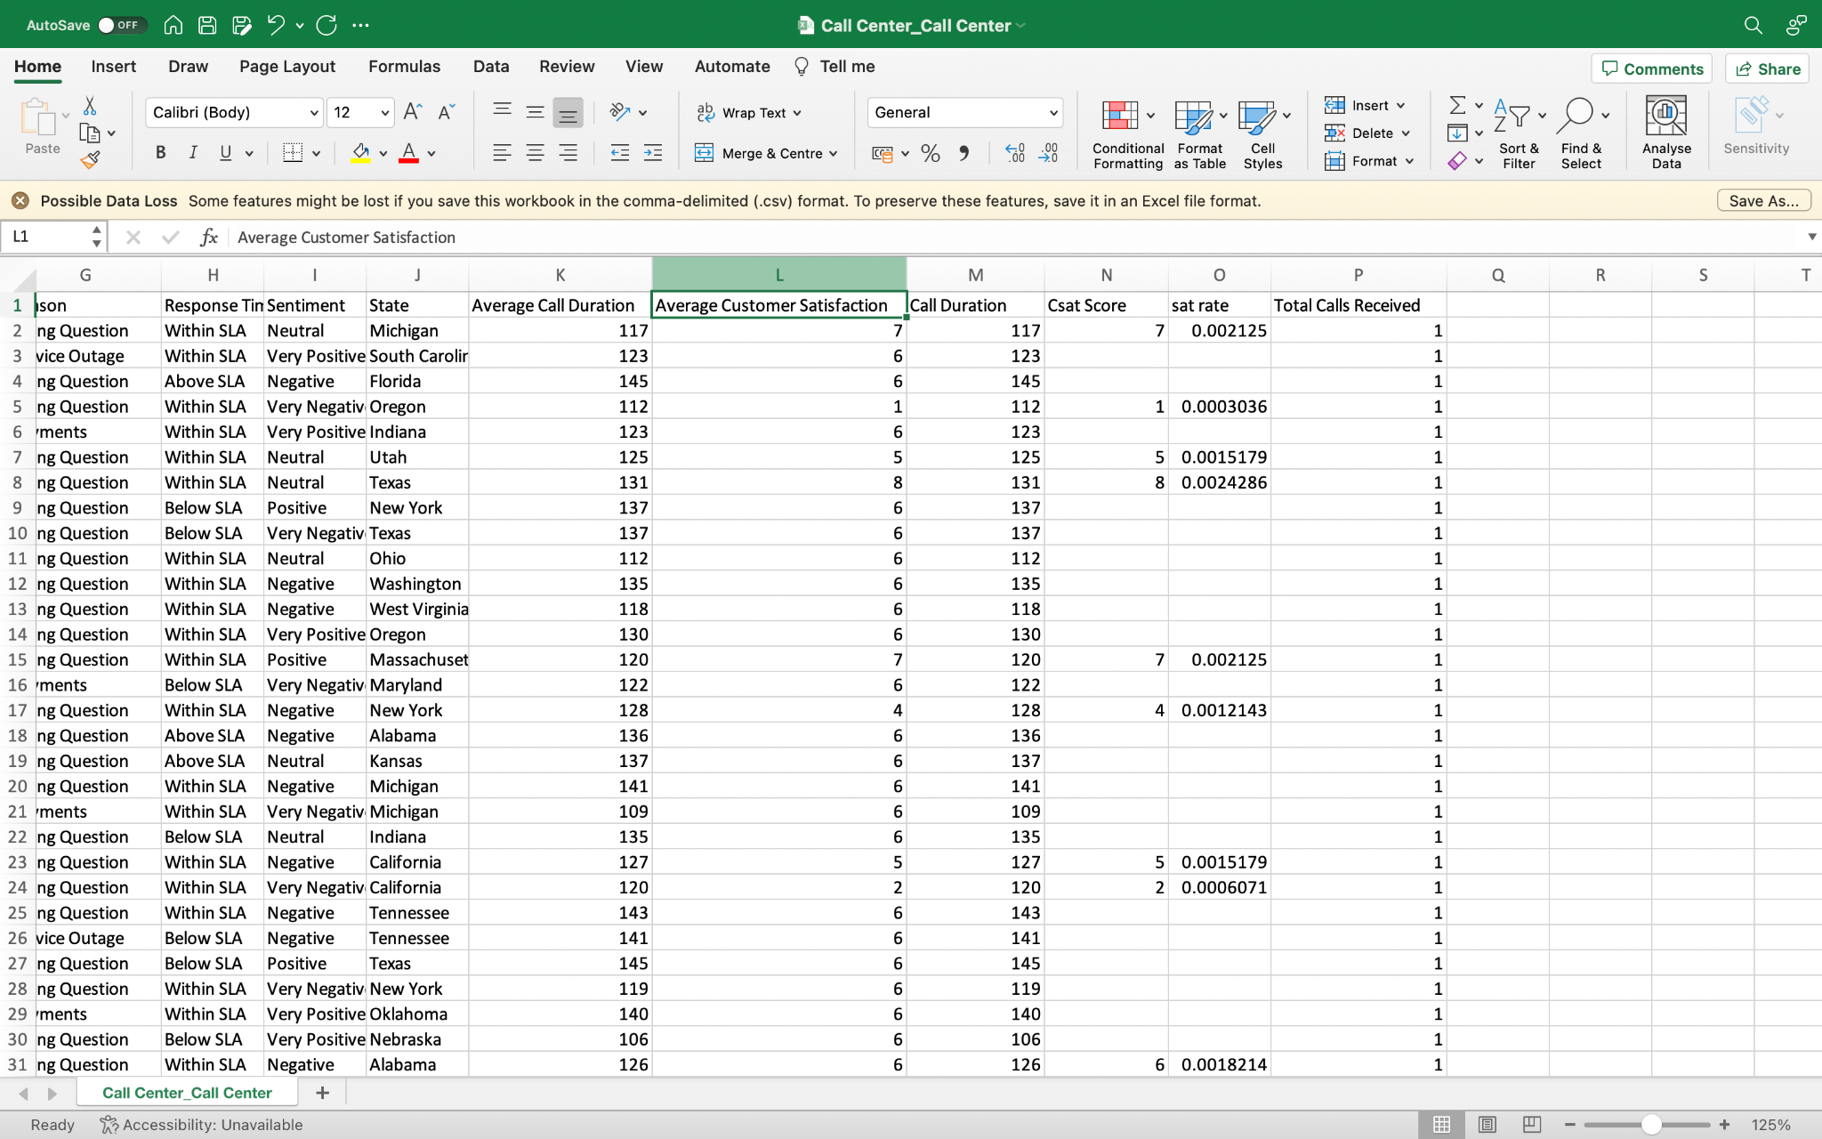

2. We have a column in our data set named “Channel” which specifies the mode of communication, This had a few “NULL” values (about 1% of the dataset). We took an average of each of the different modes of communication and assigned values based on the highest average in that category.

Pre-Data Cleaning

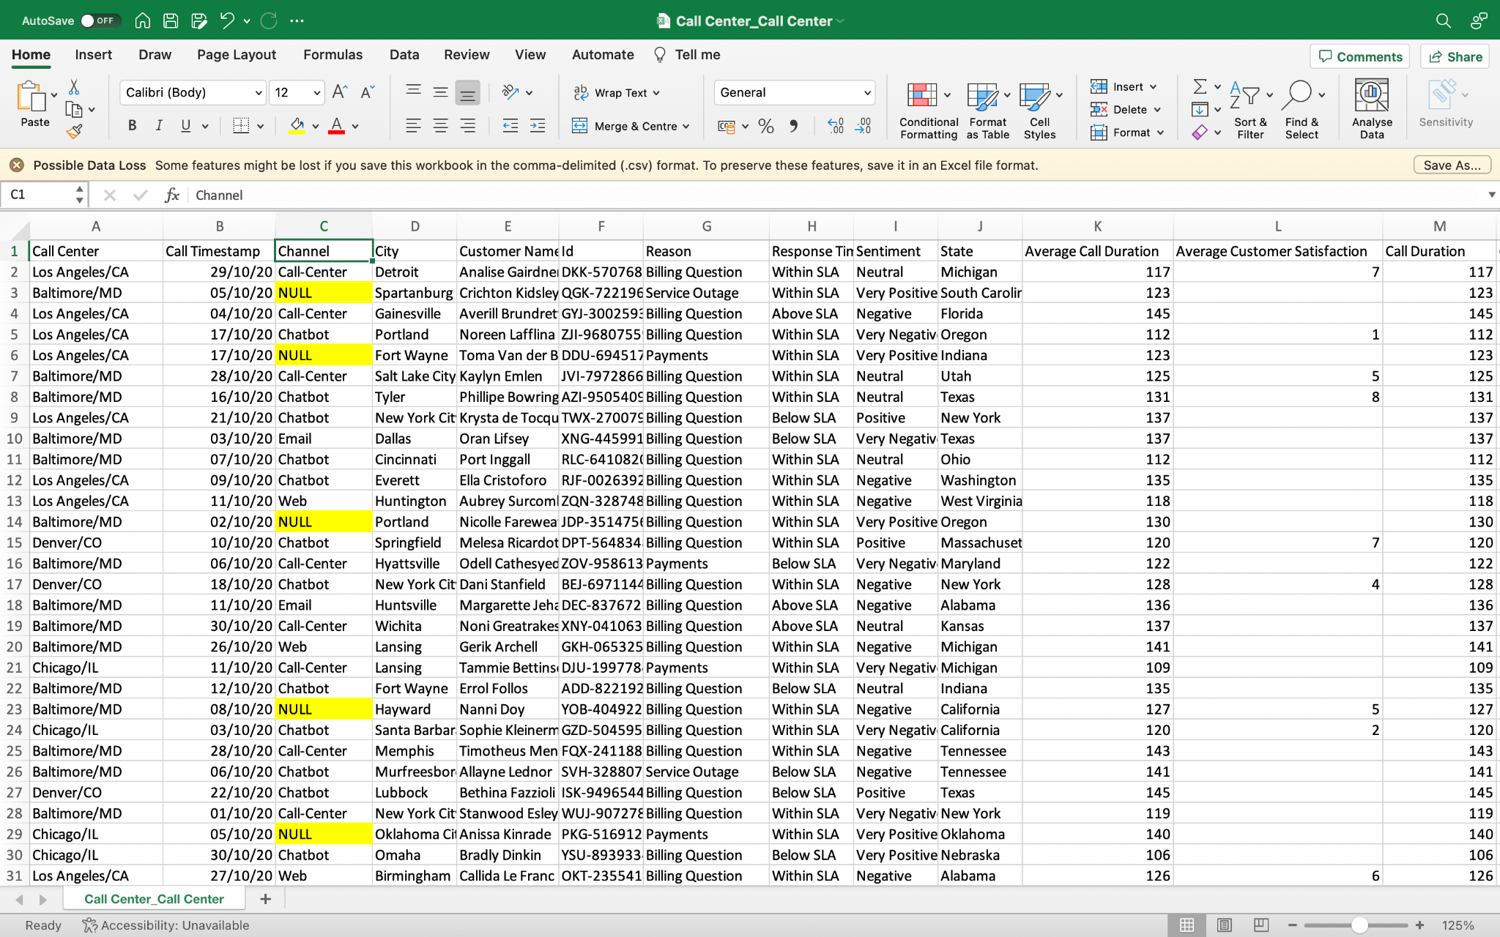

Post-Data Cleaning

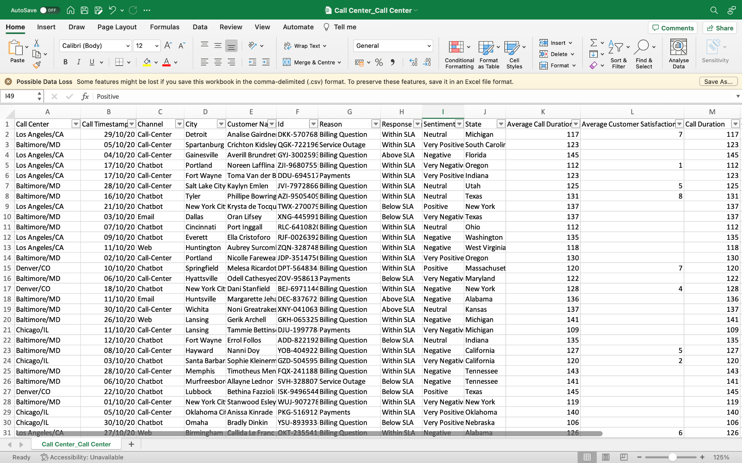

3. The column “Call Timestamp” was in the incorrect format i.e., dd/mm/yy. We changed the format to mm/dd/yyyy as per the US format.

Pre-Data Cleaning

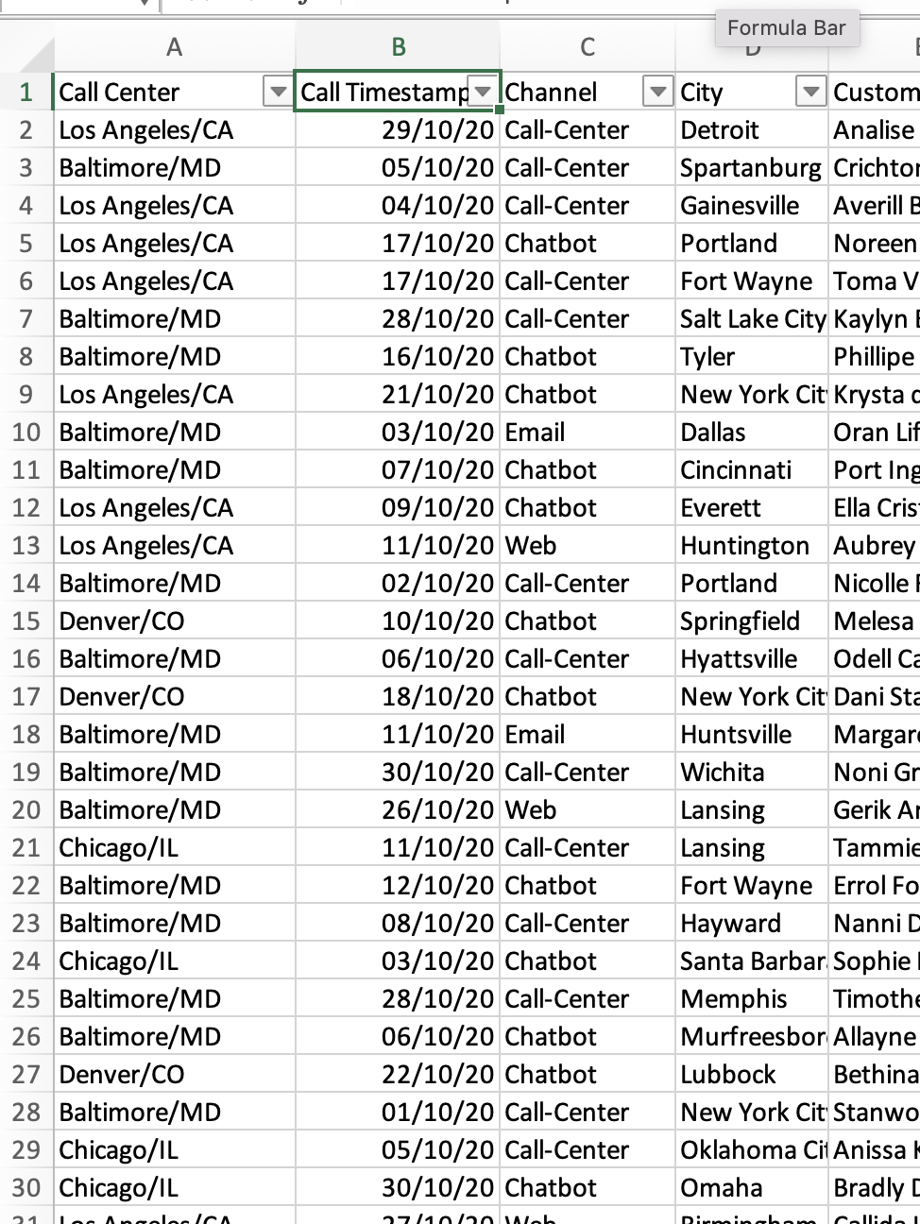

Post-Data Cleaning

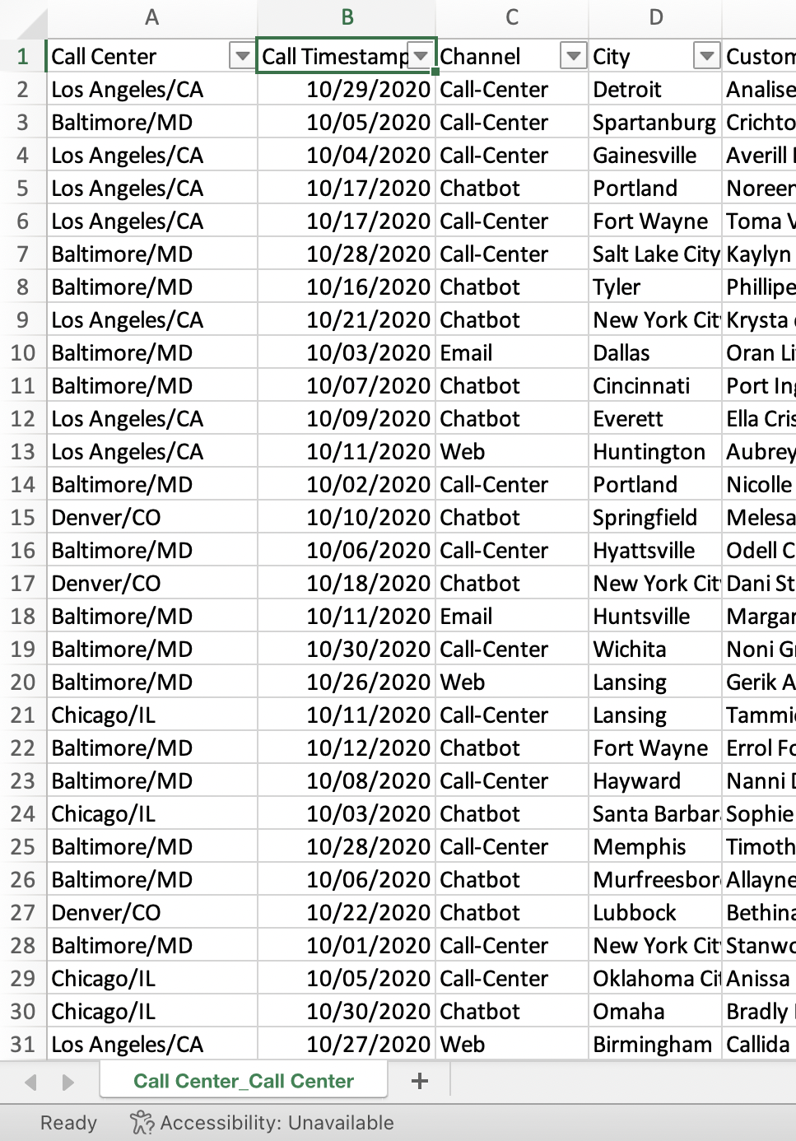

4. We have a column called “sentiment” which describes the tone of the call and is denoted by the numbers from 1 to 5, where 1 represents very negative and 5 represents very positive and 3 represents normal. We assigned the numbers with their corresponding text for better readability

Pre-Data Cleaning

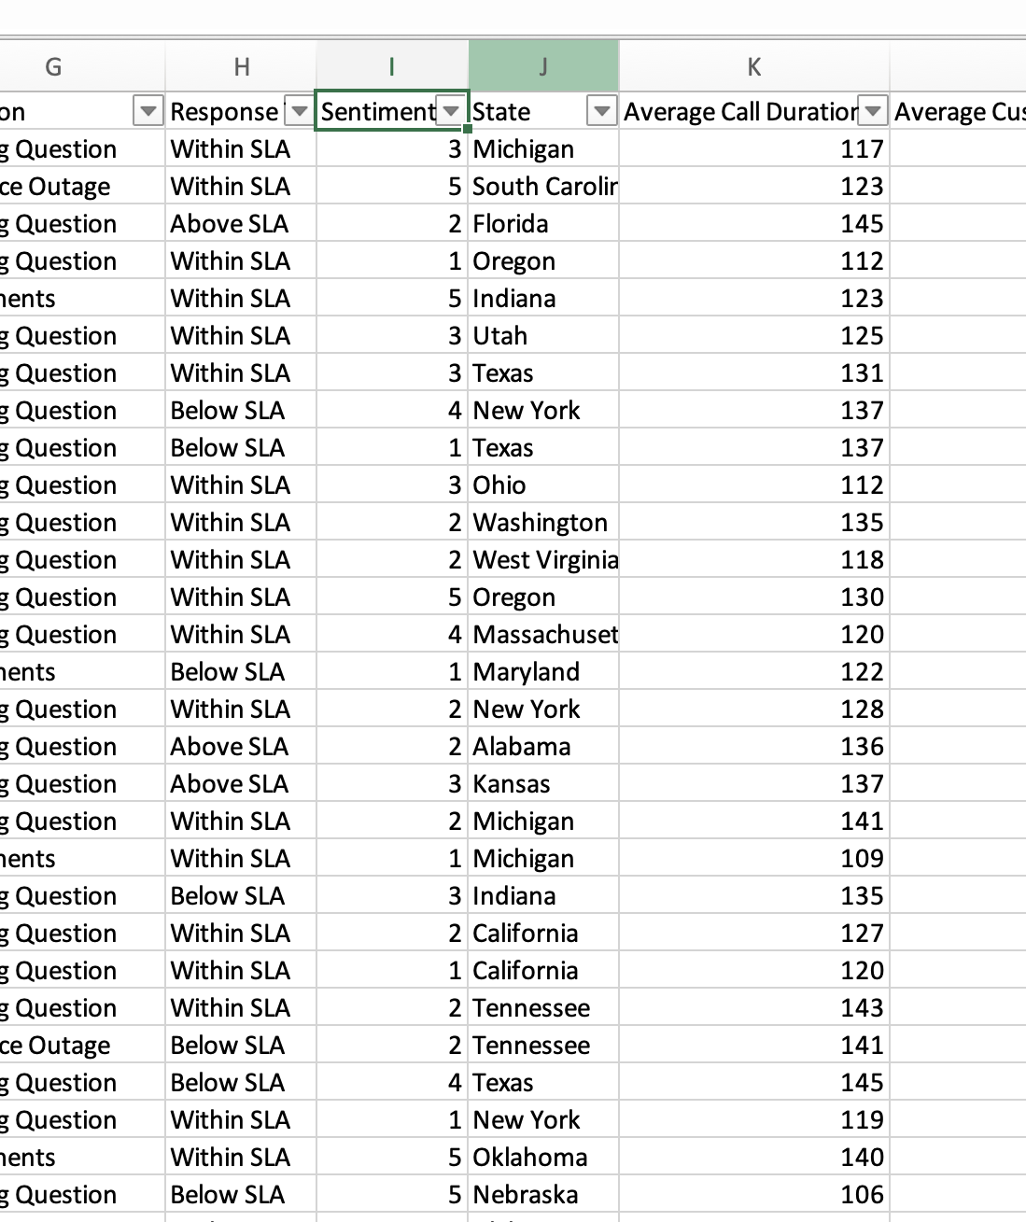

Post-Data Cleaning

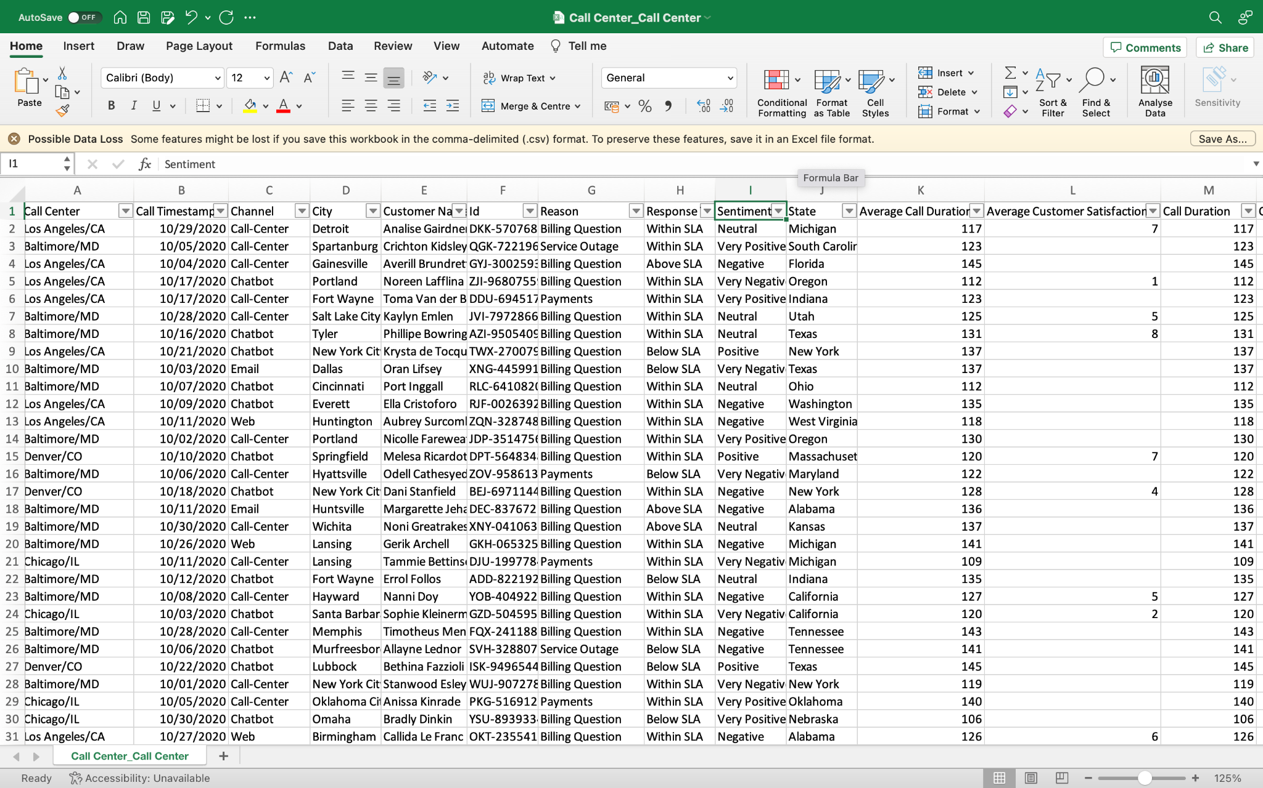

5. The column “Average call Duration” had the data in number format. We added another column to represent the data in mm:ss format by using the Excel formula “=TEXT(K3/(24*60*60),"mm:ss")”

Pre-Data Cleaning

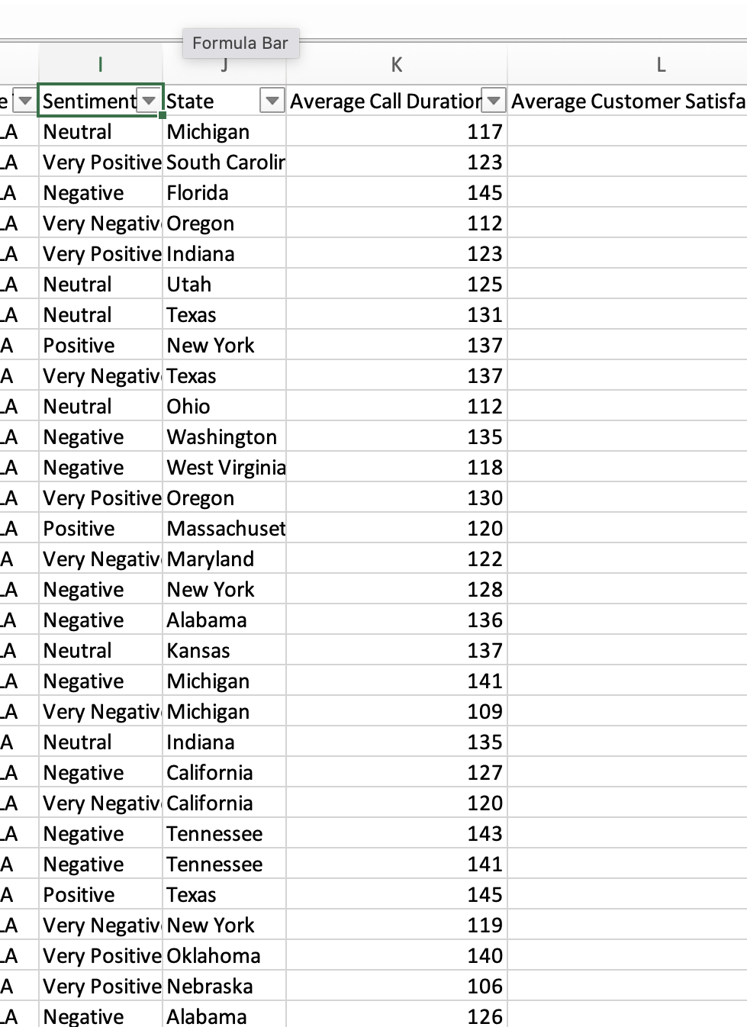

Post-Data Cleaning

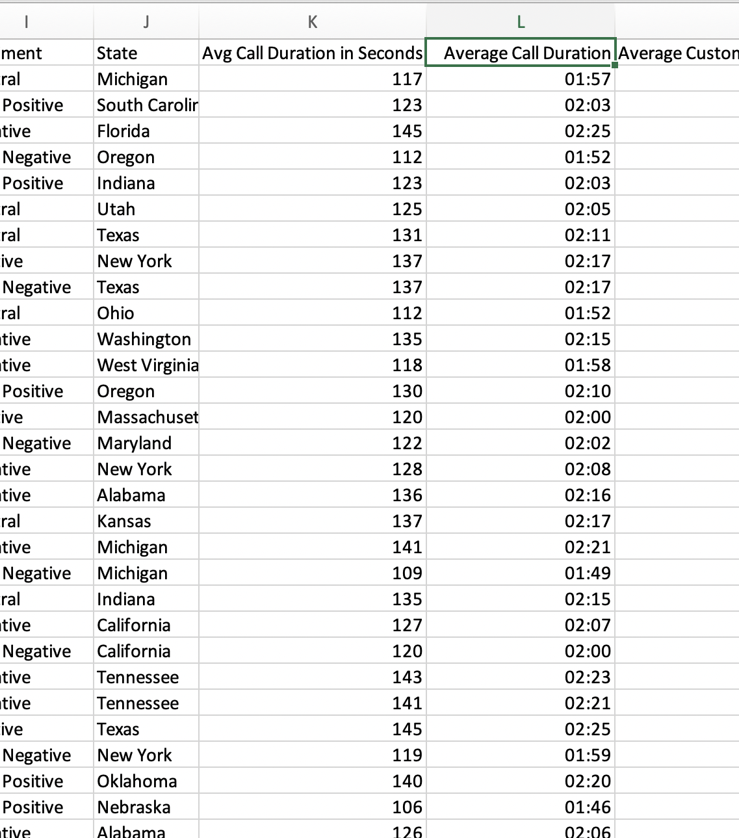

DATA VISUALIZATIONS

1. Geographic maps of the Total no of calls, Avg call length, and Customer Satisfaction with respect to the state in the USA.

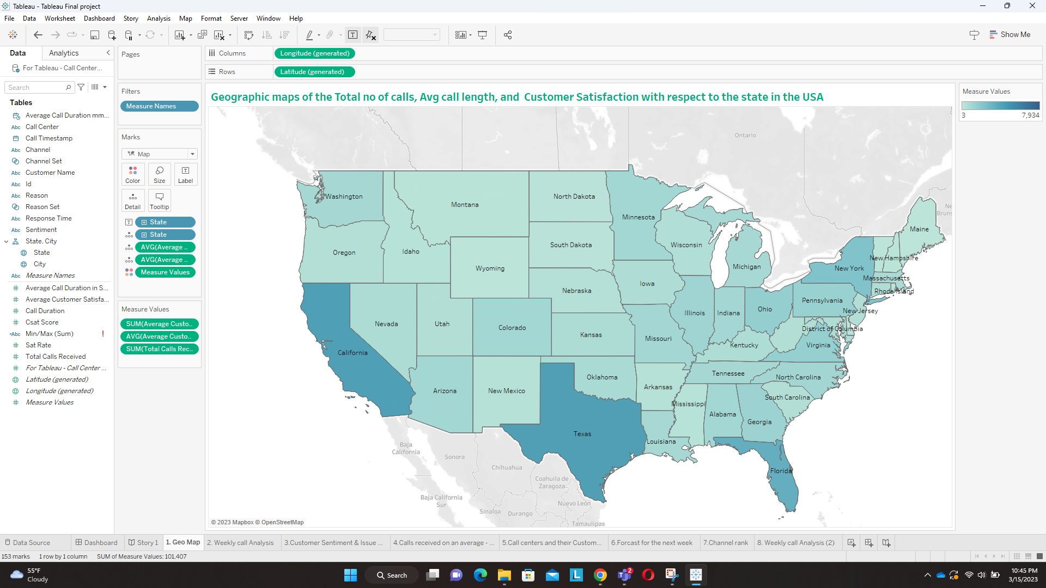

From this above map, we can see which state is receiving the highest number of calls and what is the average duration of each call in seconds. We can also see the average customer satisfaction rate in each state. In the above screenshot, you can see Texas’s records. The call centres in Texas receive 3572 calls per month, the call duration is approximately 125 seconds on an average. It also shows that the average customer satisfaction rate is 5.6

Also, It can be seen easily from the map that California has the largest amount of total calls. It can be useful to compare California and other states' data to deduct reasoning because the state with the highest population is California.

As we have columns like state and city, we have implemented Geo Maps in the above visualisation.

1. The highest number of calls based on the days of the week and channel category

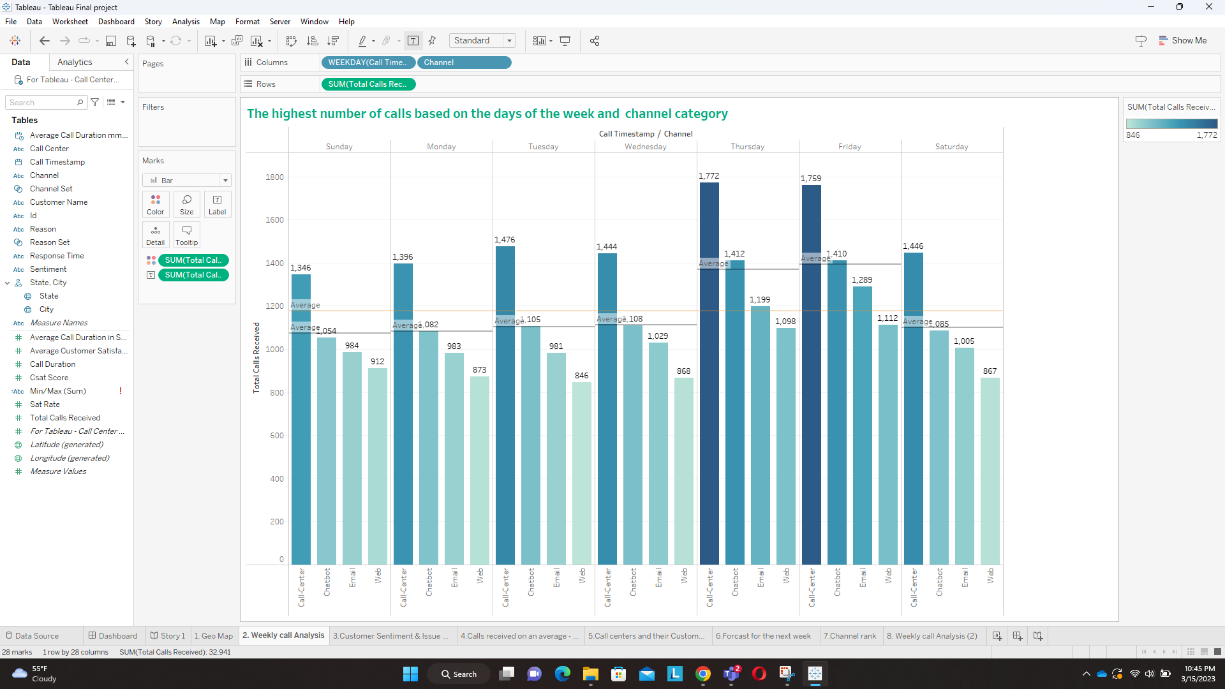

From this above chart, we can see on which day of the week we receive the most number of complaints and for what particular issue they have raised an issue. We can see on Thursday and Friday we receive the maximum number of calls and complaints from all the channels. We also see the most preferred channel to raise an issue is the call centre followed by the chatbot, email and then the web. We also show the trend line and average reference line for each weekday and the total number of calls received during a month. On the line graph, the users can see that after Thursday, there was an increase in all sentiments, because the largest amount of calls was received on Thursday and Friday. It is effective to show dates with line graphs such as changing the total number of sentiments by weekdays.

In this above visualization, we use a bar chart with an average reference line to display the average calls received for each weekday and average calls received during a span of a month.

3. Customer sentiments based on the issue category and top contributing issue type with count In this cart we try to show.

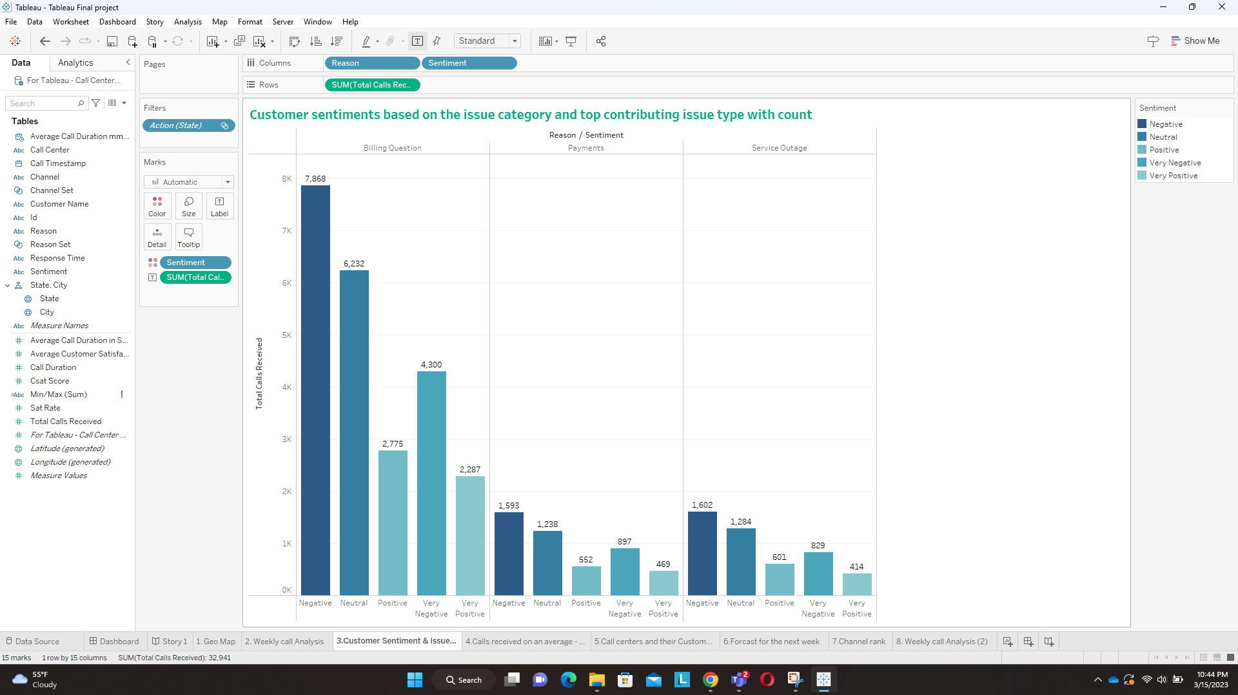

In this visualization, we can see what is the most common type of issue for which a query is raised by the customer and what is the customer feedback of the customer after the call. We see that there are three main reasons namely Billing questions, Payments and service outages. Most of the queries are raised due to billing questions followed by Service outages and then payments. We can also see the customer feedback or response after the query was raised. Was it very negative, Negative, very positive, positive or neutral feedback? From this above visualization, we can see that most of the customers had negative feedback overall. Billing questions had the highest number of negative feedback. 71.2% of the total calls, that is, 23,462 customers, called the call centres due to a billing question.

In this chart, we use a simple bar chart and we filter it out for all the states to know the overall customer sentiment for each of the corresponding issues.

4. Call centers and their customer satisfaction rate

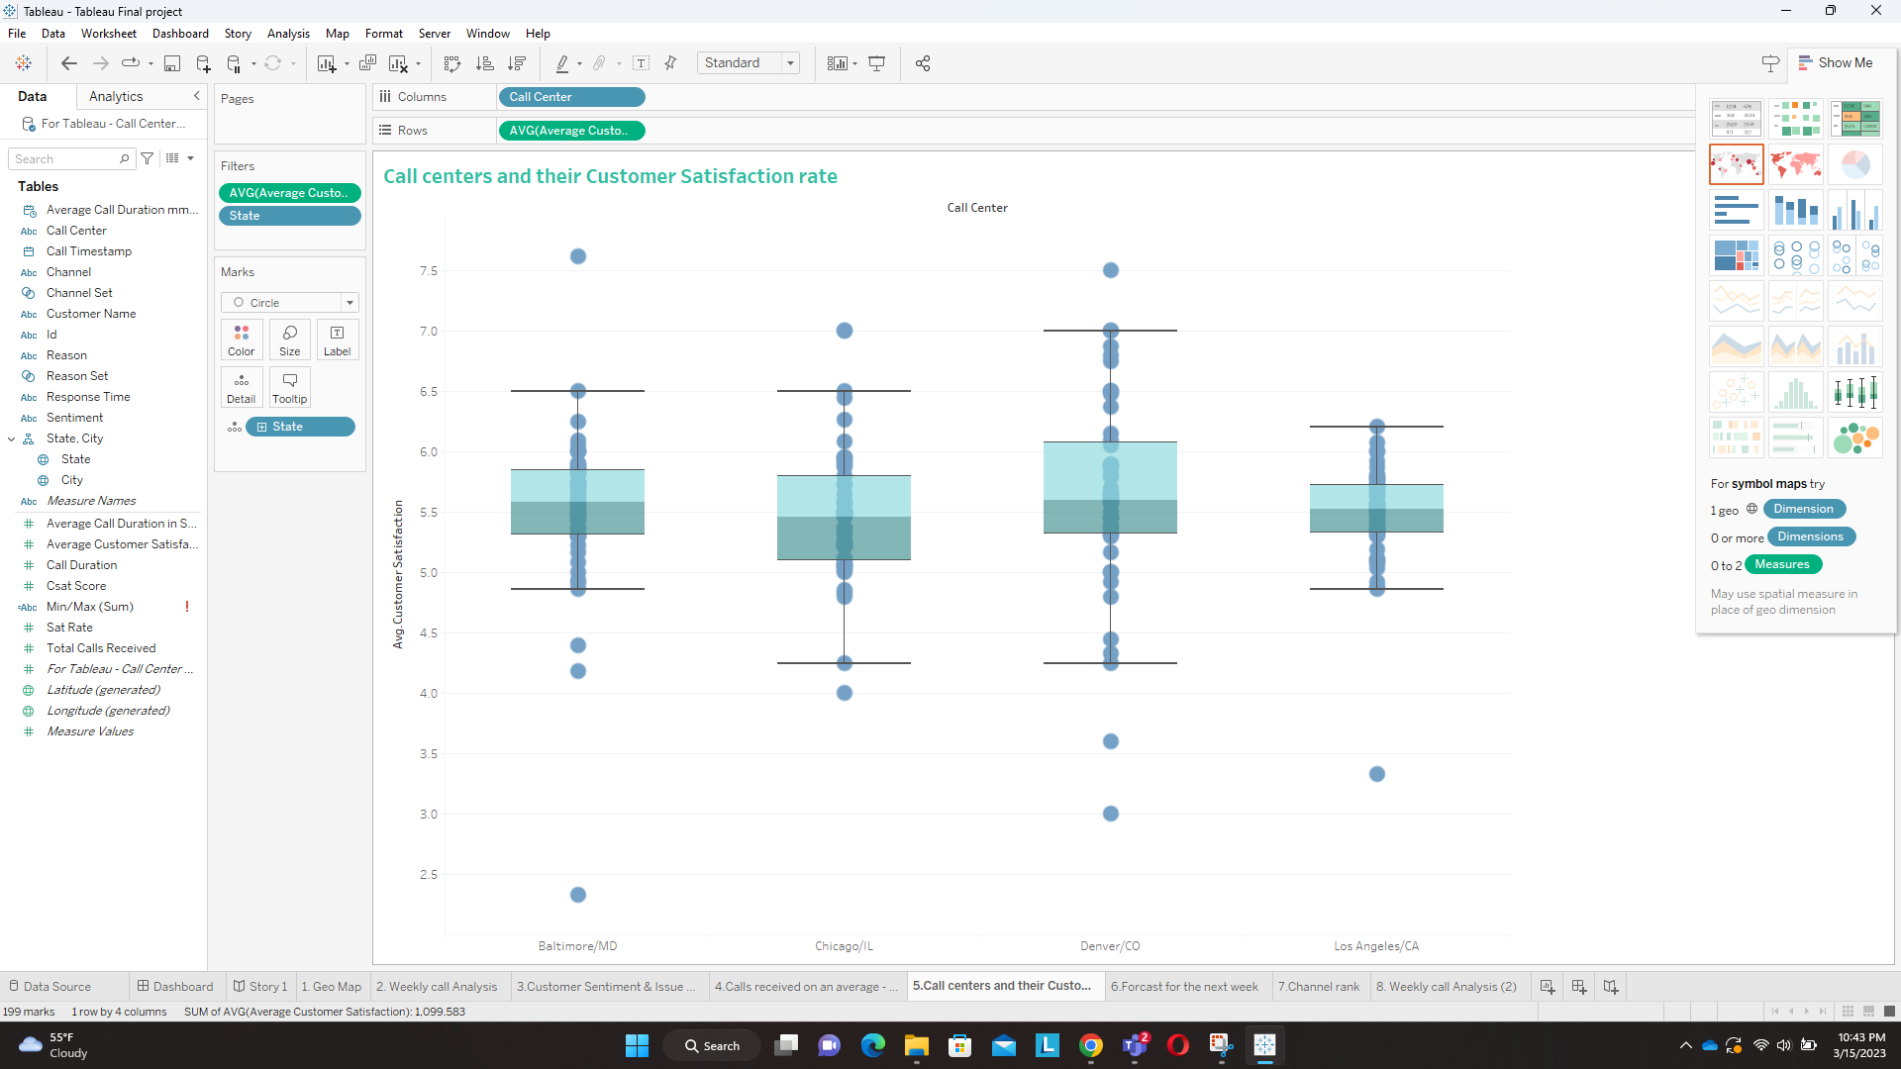

There are a total of four call centres in the united states for this specific dataset. The four call centres are picking up calls from users who are located in the united states. These four call centres are located in Baltimore/MD, Chicago/IL, Denver/CO, and Los Angeles/CA. In this chart, we try to show the customer satisfaction rate for each of these call centres. It shows the customer satisfaction rate for calls it receives from each of the states. In this chart, we see that Denver has the highest customer satisfaction rate followed by Baltimore, Los Angeles and Chicago. We can also see specific customer satisfaction for the calls a particular call centre receives from a particular state. For example, the Denver call centre has a 7.5 customer satisfaction score for calls it receives from the state of Montana.

In this visualization, we use the block and whisker plot to see the average customer satisfaction rate for each of the call centres.

5. The forecasted number of calls for the next week.

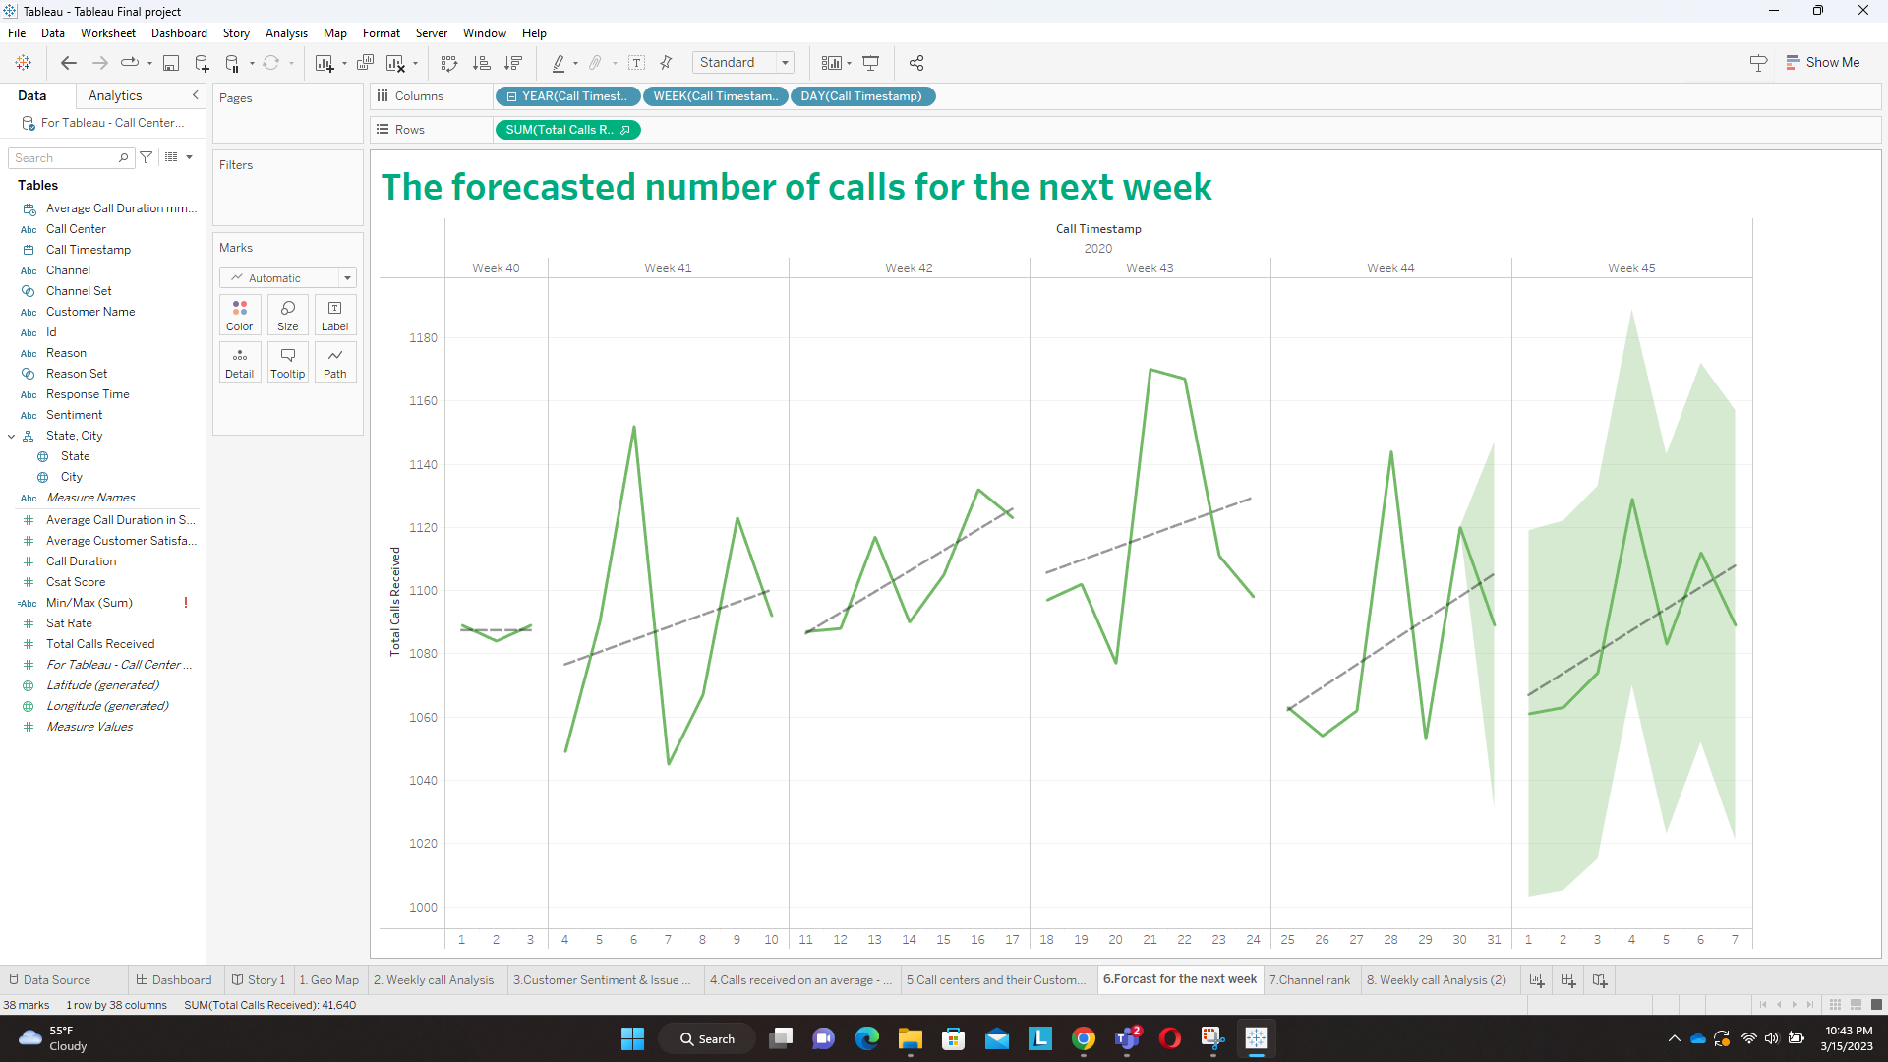

In this chart, we try to predict the number of calls the call centre might receive next week. We have October months data. We split the data into weeks, now it gives us an idea of how many calls we received during a particular week.

Now we have 4 weeks of data, and hence we can predict the following week's estimated number of calls. We have predicted how many calls we may receive in the first week of November. We also show the trend line and recalculated line.

In this cart, we have used the forecast trend lines concept and reference line to forecast next week's call volume. We have also used the concept of the date to split the data into 4 weeks.

6. Channel rank in the top five states with respect to call volume.

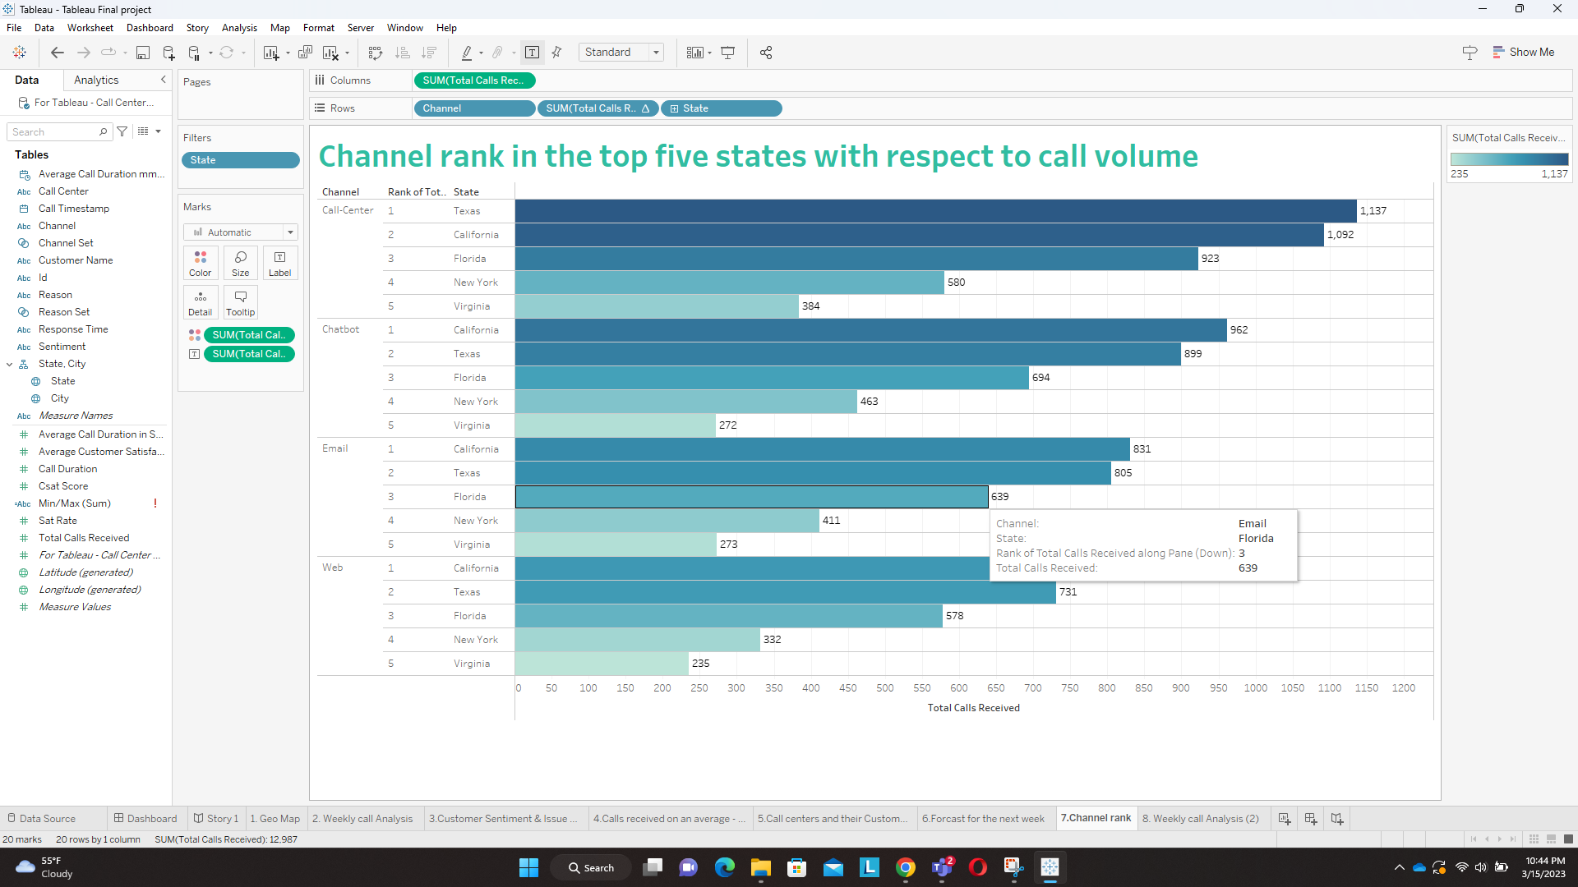

In this cart, we find out which state prefers what type of channel to address its issues. The four channels used by the company are Call-centres, chatbots, emails and the web to resolve customer issues. We rearranged the data using ranks, to find out only the top 5 states with the most call volume. We used ranks to filter out only the top 5 states, cause previously we had data for all the states which made the visualization very lengthy and difficult to read.

From this above visualization, we can see that people in Texas prefer solving their issues via a call center while users in California prefer solving their queries over the chatbot.

We have displayed the above findings using a simple bar diagram with ranks to find out the states and their preferred communication mode.

DASHBOARD

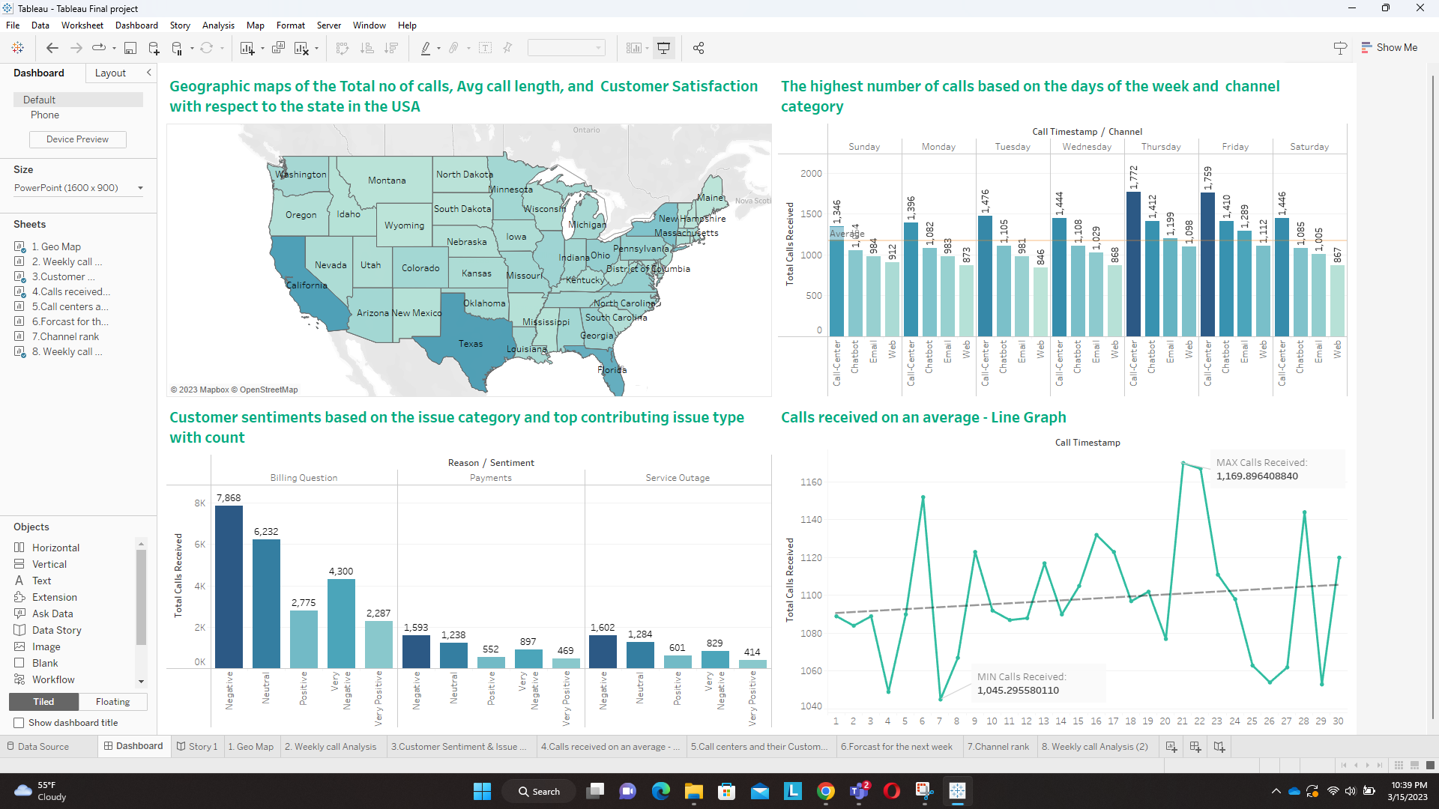

The dashboard aims to show some general specifications of the call center and States. It contains several visuals which all can be filtered by state to show the specifications. For instance, the States map is in accordance with the total number of calls received to show which state is the busiest in terms of calls, and it is always useful for the users to compare those states with others. It helps you to observe the data from a wide perspective of the states.

You can select each state individually to know the toilet number of calls it receives on a particular day, what was the customer feedback for each of its call and using which channel most of the issues were sought out. We also show the customer satisfaction rate and average duration of the calls for each of the states. You can see a map distributed proportionally with shades of green based on the total number of calls. The darkest hue indicates the busiest state in terms of total calls. we chose the map to show this data because it is the proper way to show that geographical data and all states are distributed.

Knowing where your customers come from and how they reach you is often helpful and gives ideas about what to do with your business. Getting to know customers means you can always offer them better services or offers. To show the most popular cities and channels which are

used to reach the call centers, we chose a bar chart because helps to compare the different sets of data among different groups easily.

The chart we used especially for the dashboard is the following.

Calls received on an average - Line Graph. We used this chart so that when the user clicks on a particular state in the Geo-Map, he/she can see the total number of calls a state receives on a particular day. We also display the average trend line for the line graph.

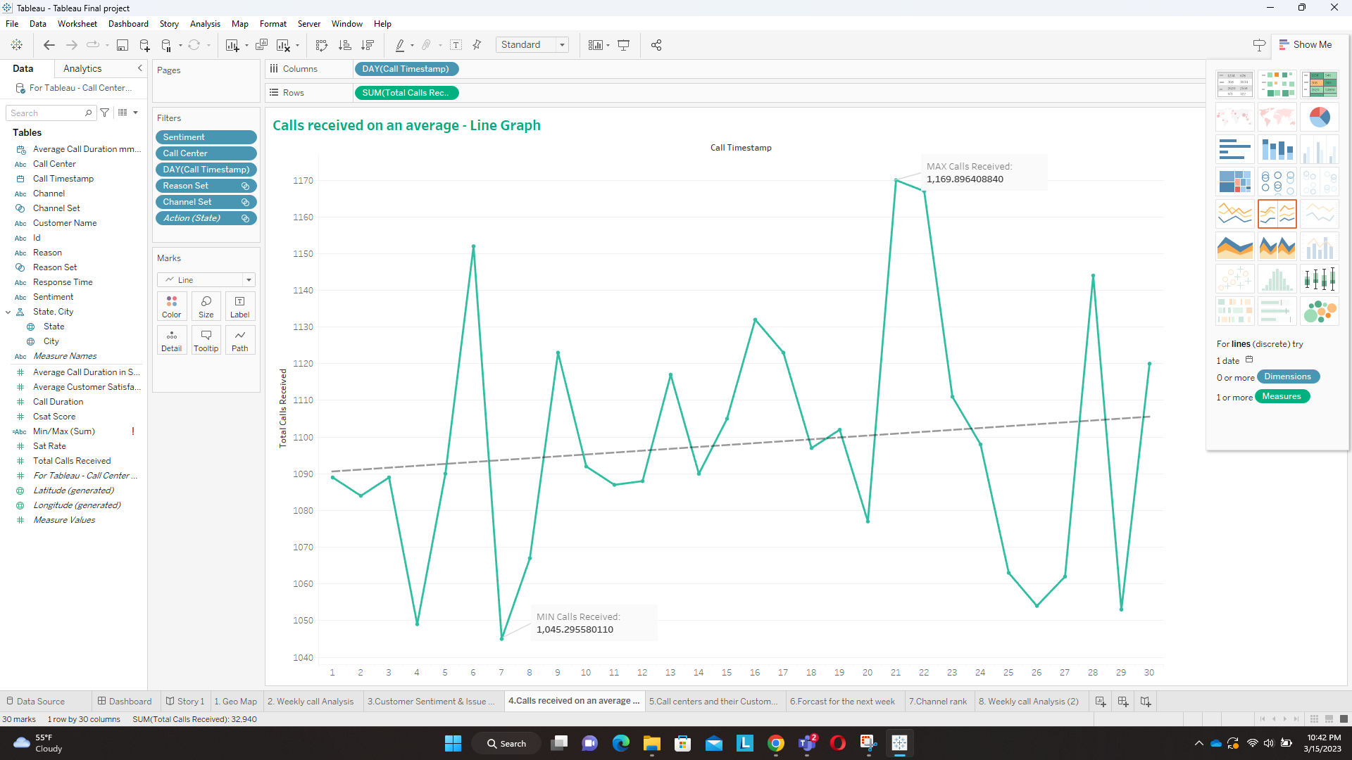

STORYBOARD

1. The total number of calls received on a daily basis across the United States.

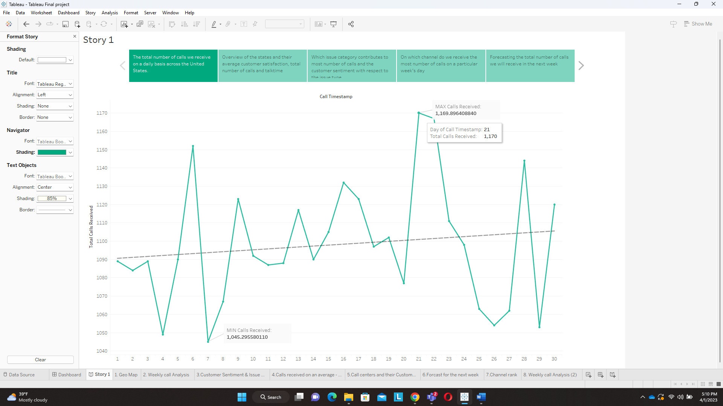

One of the key metrics to measure the performance of a customer service center is the number of calls received daily. In this analysis, we will be presenting a line graph that illustrates the total number of calls received daily across the United States over the past 30 days.

The line graph shows the total number of calls received daily across the United States over the past 30 days. The x-axis represents the number of days, while the y-axis represents the total number of calls. Each point on the line represents the total number of calls received on that particular day.

The line graph shows that the total number of calls received daily across the United States has been fluctuating over the past 30 days. There is a clear pattern of spikes in the number of calls received on certain days, followed by a decrease in the number of calls on the following days. For example, on Day 7, the total number of calls received was 1,045, which was the least recorded, and on Day 21 the number of calls recorded was 1,169, which was the highest.

By monitoring and analyzing this data, we can identify any potential issues early on and take proactive steps to address them before they become larger problems. Overall, this line graph provides us with valuable insights into the volume of calls we are receiving, allowing us to make informed decisions that benefit both our customers and our business.

1. Overview of the states and their average customer satisfaction, the total number of calls, and talk time

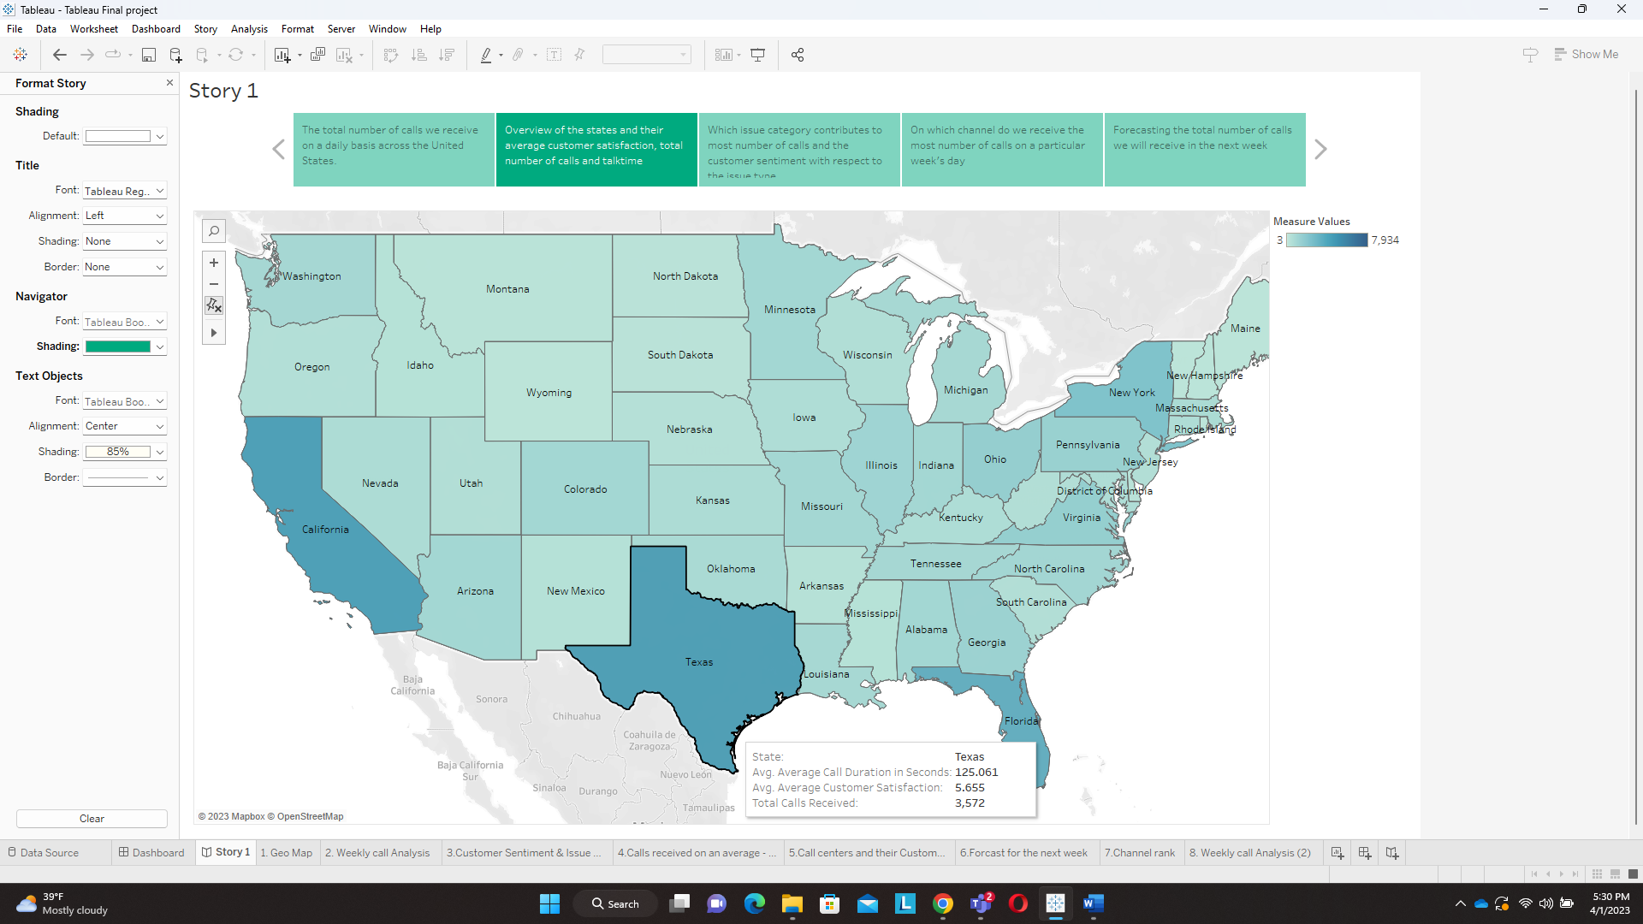

After analyzing the daily call volume, we wanted to deep dive and see how each of the individual state’s customer satisfaction, total no. of calls, and talk time was compared to the other states in the US.

The data visualization we used to present our findings was a Geo map that showed the average customer satisfaction, total number of calls, and talk time for each state.

The map is color-coded, with shades of dark green representing higher call volumes satisfaction and shades of lighter green representing lower levels. Upon hovering over each state, info text provides us with the details of customer satisfaction, avg talk time and call volume.

Upon analyzing the map, we discovered that states with higher levels of customer satisfaction tended to have lower average talk times per call. In contrast, states with lower levels of customer satisfaction had higher average talk times per call. This suggests that customers in less satisfied states may be more likely to engage in longer conversations with customer service representatives.

Another interesting trend we noticed was that states with higher populations tended to have a higher total number of calls received. This is likely due to the fact that larger states have more customers who require customer service assistance.

Overall, the world map was a useful tool in visualizing and understanding customer data across different states. It allowed us to easily identify trends and patterns and helped us make informed decisions about how to improve customer satisfaction and optimize customer service processes.

1. Which issue category contributes to the most number of calls and the customer sentiment with respect to the issue type.

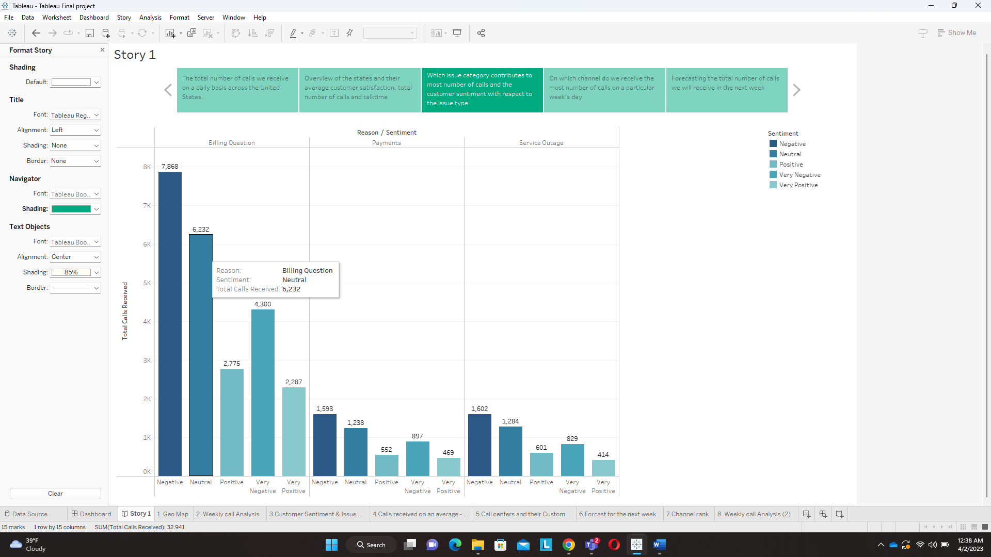

we have analyzed the data of the customer service calls to gain insights into which issue categories contribute to the most number of calls and the customer sentiment with respect to each issue type.

To understand this, we created a bar graph that represents the total number of calls received for each issue category and the corresponding customer sentiment for each issue type.

Upon analyzing the data, it was found that billing question issues were the most common reason for customers to call customer service. A total of 71.2% of calls received were for billing questions.

When it came to customer sentiment, it was found that customers who called in with billing-related issues had mixed sentiments. About 52.33% of customers’ sentiment was very negative or negative with the resolution provided by the customer service representatives, while the remaining 47.77% of customers were positive and neutral.

The second most common reason for customers to call was related to payments, with 14.4% of calls received being for this issue category. Customers who called with payment inquiries had similar sentiment as that of the first issue category.

Another issue category was service outage which comprised the remaining 14.4% of calls received.

Overall, the data from the bar graph suggests that billing and payment issues are the biggest pain point for customers and that the customer service team should focus on improving customer satisfaction in this area.

1. On which channel do we receive the most number of calls on a particular week's day

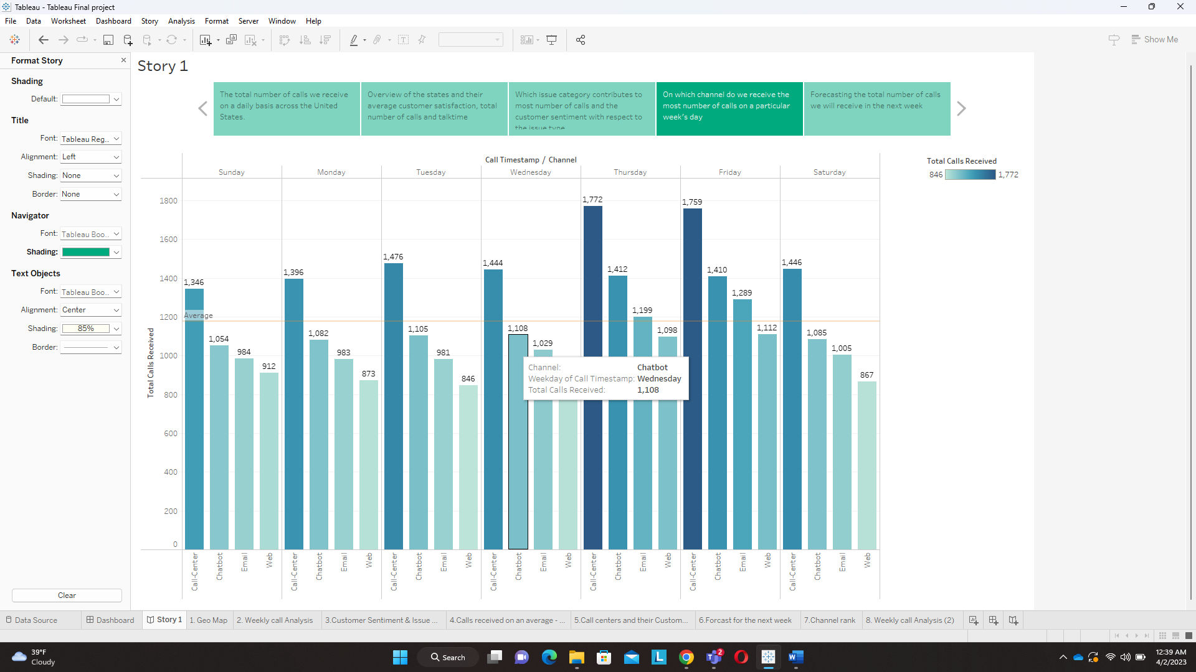

Looking at the graph, it is clear that the company receives the most number of calls on Thursdays & Fridays, with Thursday being the busiest day. The highest number of calls is received on the phone channel, followed by chat, email, and web channels. The company receives the least number of calls on Monday.

It is interesting to note that while the phone channel receives the most number of calls overall, there is a significant drop in the number of calls on Monday. On the other hand, the email channel sees a spike in the number of calls on Fridays.

Overall, this data highlights the importance of having adequate staffing and resources for the phone channel, particularly on weekdays. It also suggests that the company should consider dedicating more resources to the email channel on Fridays to manage the increased volume of calls.

1. Forecasting the total number of calls we will receive in the next week

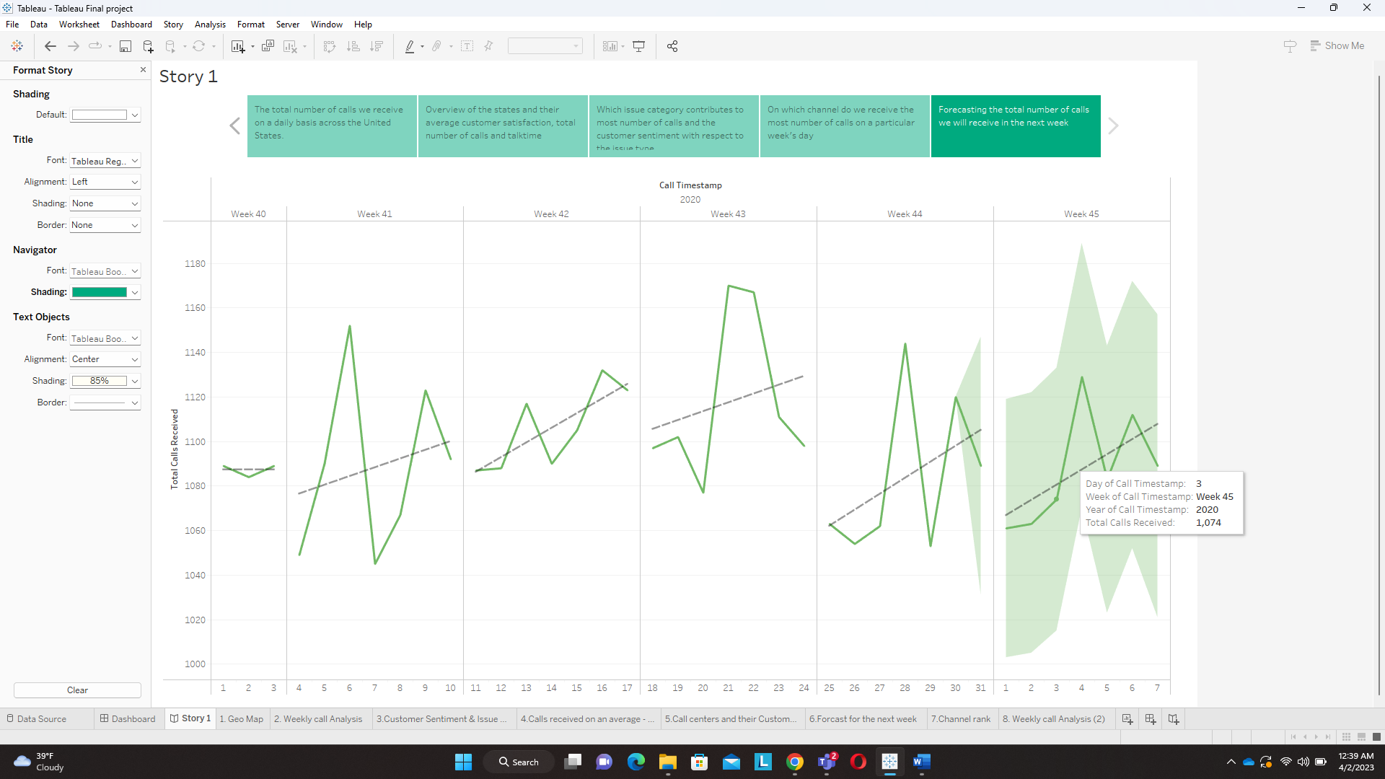

it is essential to analyze and forecast the number of calls the company is expected to receive in the future. The following is a story on forecasting the total number of calls the company is likely to receive in the next week based on the previous month's trend.

Looking at the line graph, we can see that the company has received an increasing number of calls in the past month. The total number of calls received has steadily increased. Using this trend as a basis, we can forecast that the company will continue to receive an increasing number of calls in the next week. On the first day of the new month, we predict that the company will receive approximately 1,061 calls. This number is based on the average number of calls received on the first day of the previous month.

As the week progresses, we expect the number of calls to increase, peaking on Thursday with an estimated 1,129 calls. This is based on the trend observed in the previous month, which saw an increasing number of calls throughout the week, peaking on Thursday and decreasing on Friday.

Based on this forecast, the company can prepare to handle an increasing number of calls in the upcoming week. They can schedule more staff members to handle the calls and ensure that they have sufficient resources to handle any potential increase in call volume.

It is important to note that while this forecast is based on the previous month's trend, there are several factors that can impact the actual number of calls received. These include external factors such as holidays, weather conditions, and marketing campaigns. Therefore, it is important to continually monitor the call volume and adjust the forecast accordingly.

References

(1) Brown, L., Gans, N., Mandelbaum, A. Sakov, A., Shen, H., Zeltyn, S., and Zhao, L. (2002),

(2)“Statistical analysis of a telephone call center: A queueing-science perspective”, Technical

Report, University of Pennsylvania.

(3) Brown, L., and Zhao, L. (2002) “A new test for the Poisson distribution”, Sankhya: The

Indian Journal of Statistics, Series A, 64, 611-625.

(4)Gans, N., Koole, G., and Mandelbaum, A. (2002), “Telephone calls centers: a tutorial and

literature review”, Technical Report